INTERNATIONAL HELVI SIPILÄ SEMINAR  Helvi Sipilä (1915 – 2009) was a Finnish lawyer, diplomat and the first female Assistant Secretary-General of the UN. Sipilä received numerous national and international awards including twelve honorary doctorates, and she was granted the honorary title of Minister in 2001. She also held leadership position in several associations, including the International Federation of Women Lawyers and the International Council of Women.  Helvi Sipilä’s profession in law was exceptional at the time. When she announced the opening of her own law firm in 1943, she became the second woman in the Finnish history to practice as a lawyer. She ran her own law firm for 30 years. Private entrepreneurship enabled her to engage in extensive social activities, including service as a member of governmental missions.  While Assistant Secretary-General, she was appointed Secretary-General of the UN World Conference on Women in Mexico 1975. She continued to work as a consultant for the UN until 1981, in order to promote the UN Voluntary Fund for the Advancement of Women, later known as UNIFEM (part of UN Women), set up during the UN Decade for Women 1976 - 1985.  Helvi Sipilä was a well-known and respected advocate for equality and women’s rights. Her important legacy will live on. The first international Helvi Sipilä Seminar was organized at the CSW50 in 2006 by the Finnish Federation of University Women (FFUW) in collaboration with four other Finnish Women’s organizations to honor the work of Minister Helvi Sipilä. | 15th International Helvi Sipilä Seminar  MY BODY IS MINE – Trafficking in Human Beings  – How to Protect Women and Girls?  International Women’s Day, Monday 8th March 2021  at 16.00 – 17.30 (Helsinki time, UTC/GMT +2 hours)  THE INTERNATIONAL HELVI SIPILÄ SEMINAR series  addresses challenging issues that affect women and their lives  locally and globally in the 21st century. The event organized during the CSW65 is the 15th seminar in this series.  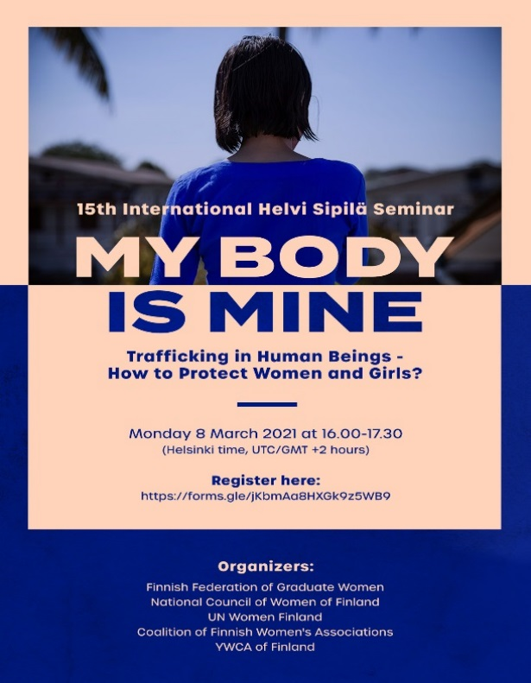
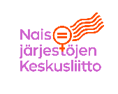
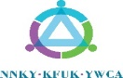
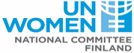
PROGRAM  Chair of the seminar & opening  My Body is Mine! Women’s organizations countering the anti-gender movement  Eva Biaudet, MP, President of the the National Council of Women of Finland  Finland’s commitments towards gender equality and women’s rights  Thomas Blomqvist, Minister for Nordic Cooperation and Equality of Finland  Gender dimension - recognized risks of women and children in conflicts  Helena Ranta, Professor at The Department of Forensic Medicine at the University of Helsinki  Panelists  Venla Roth, Ministerial Adviser, Department for Criminal Policy and Criminal Law, Criminal Procedure, Ministry of Justice, Finland  Tatiana Kotlyarenko, Advisor on Anti-Trafficking Issues at Organization for Security and Co-operation in Europe at the Office for Democratic Institutions and Human Rights  Nirmala Gurung, Young Women’s coordinator  YWCA Nepal  Closing  Katri Viinikka, Ambassador for Gender Equality, Ministry for Foreign Affairs of Finland | CONCEPT NOTE  CSW65 – 15th INTERNATIONAL HELVI SIPILÄ SEMINAR  International Women’s Day, 8 March 2021  Trafficking in human beings (THB) is a serious human rights violation and has been defined as a form of gender-based violence under international law. Women and girls are disproportionately affected and are usually trafficked for the purpose of economic and sexual exploitation. With the title of My body is mine – how to protect women and girls our distinguished speakers will examine different forms of trafficking in human beings, their effects on victims and what should be done to protect women and girls who have fallen victim to trafficking.  Eva Biaudet (MP, President of the the National Council of Women of Finland) will open the seminar and speak on the role of women’s organizations in fighting the anti-gender movement.  Thomas Blomqvist (Minister for Nordic Cooperation and Equality of Finland) will present Finland’s commitments towards gender equality and women’s rights.  Helena Ranta (Professor at The Department of Forensic Medicine at the University of Helsinki) will speak on the gender dimension of the recognized risks of women and children in conflicts.  Panel  My body is mine – how to protect women and girls  The distinguished speakers of our panel will examine THB from various viewpoints. What are some of the main challenges of tackling THB? What can be done to prevent women and girls from falling victim to THB? What is the role of States and institutions? How is THB a form of gender-based violence?  Katri Viinikka (Ambassador for Gender Equality, Ministry for Foreign Affairs of Finland) will close the seminar.  The seminar is organized jointly by the Finnish Federation of Graduate Women,  the National Council of Women of Finland, the Coalition of Finnish Women’s Associations – NYTKIS, Finland National Committee for UN Women and  the Young Women’s Christian Association of Finland YWCA.

